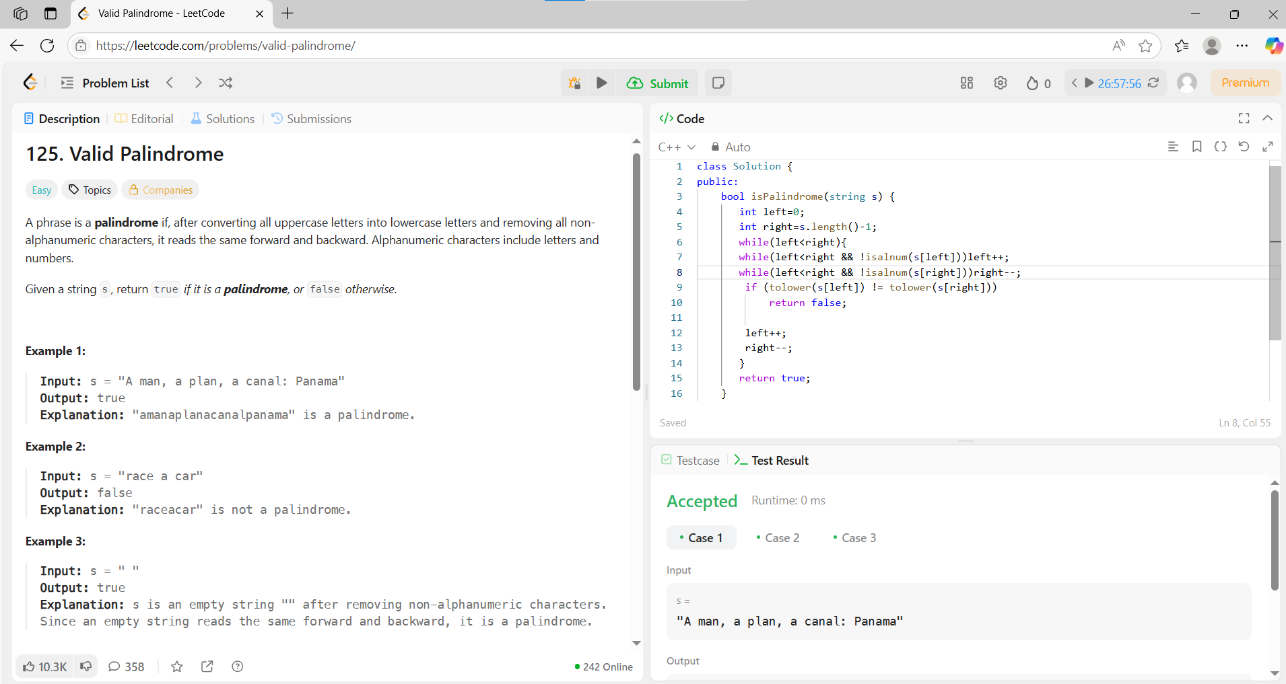
->use isalnum()-> to check if it’s a alphabet or not above code is example
-> vector<int> hash(n+1);
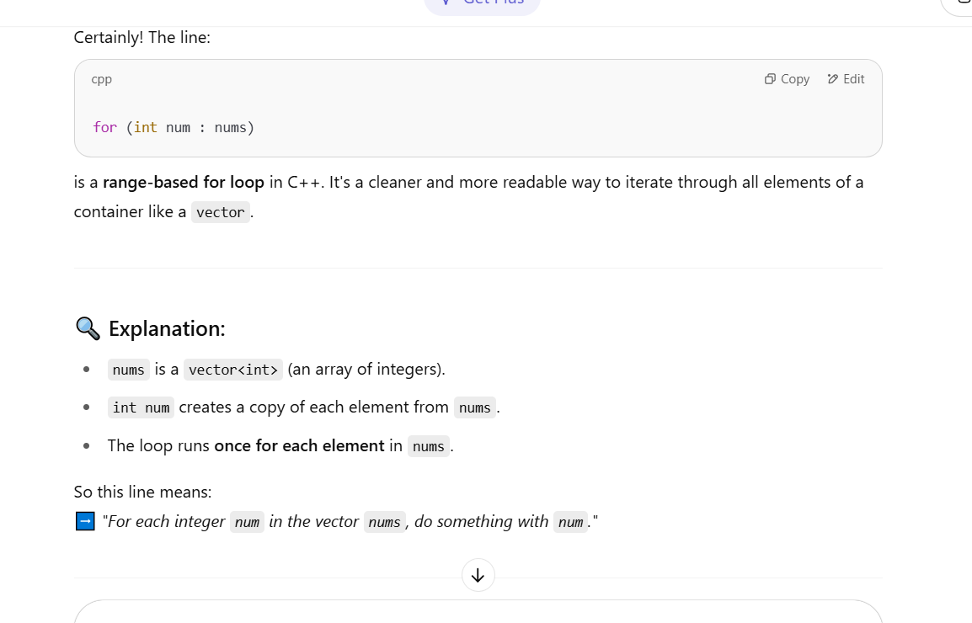
For returning max or min element in array it should return a pointer so->
*max_element(arr.begin(),arr.end())
For sum of elements->
accumulate(arr.begin(),arr.end(),0)

